**CSE 3063 Fall 2020 Java Project 1**

**Group Number 14**

**Iteration 2 Requirement Analysis Document**

**1. Description**

This software is designed to process Zoom poll reports and grade the participants. Polls are containing questions and answers that participants gave. Participants’ answers can be correct or wrong and participants(in this case students) must be graded for their choices.

In our project, we can read the poll data from a csv file and analyze it so we can give a detailed report to the instructor about how each student performed in the quiz and each question.

These results are needed for measuring students’ participation in class when conventional education can not be performed and lectures can only be done over the internet. Results are detailed enough for measuring any student’s attendance to class and knowledge about that lecture. Because we can see both the time and date of the quizzes and the quiz grades.

**2. Requirements**

**2.1** The program should provide statistics based on given data.

**2.2** Datasets should be given in csv files.

**2.3** The program should read the dataset from these csv files.

**2.4** The program should differ multiple quizzes from a single input file.

**2.5** After reading the dataset from csv files, the program should generate a database from the given student list.

**2.6** For measuring knowledge, the program needs to process multiple questions and answers.

**2.7** After the processing is done, the program should create the output as a csv file.

**3. Glossary of Terms**

**3.1** **Quiz:** A group of questions which are asked to students.

**3.2** **Question:** Questions are asked by the tutor to test knowledge of students. A question may have more than one answer.

**3.3 Student:** People who attend an online meeting.

**3.4** **Answer:** Answer is the given result from a student to a question.

**3.5 CSV:** A delimited text file that uses comma to separate values. In this project csv files will include the data of student names, student ID’s, questions and answers.

**4. Use Cases**

**4.1** Taking attendance for an online class.

**4.2** Measuring student knowledge on lectures.

**4.3** Can be used for any online meeting with high participation.

**5. Domain Model**

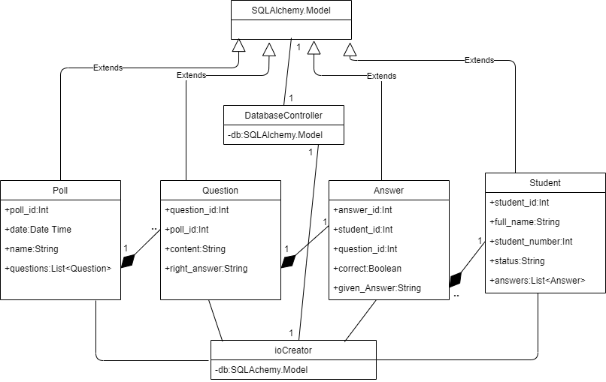

**6. System Sequence Diagram(SSD)**

